Cursillo in Christianity Golf Shirt Fund Raiser Order Form

Name_____________________________________
Address ____________________________________________________
Phone Number ______________________________________________
Number of Shirts Ordered ________________
Total Payment _________________
Color | XS | S | M | L | XL | XXL | XXXL
Red
Orange
Yellow
Green
Blue
Purple
For the Cursillo in Christianity Diocese of East Carolina shirt please indicate sizes and color below
Cursillo in Christianity
Diocese of East Carolina
These come in Red,
Orange, Yellow,
Green, Blue, and
Purple.

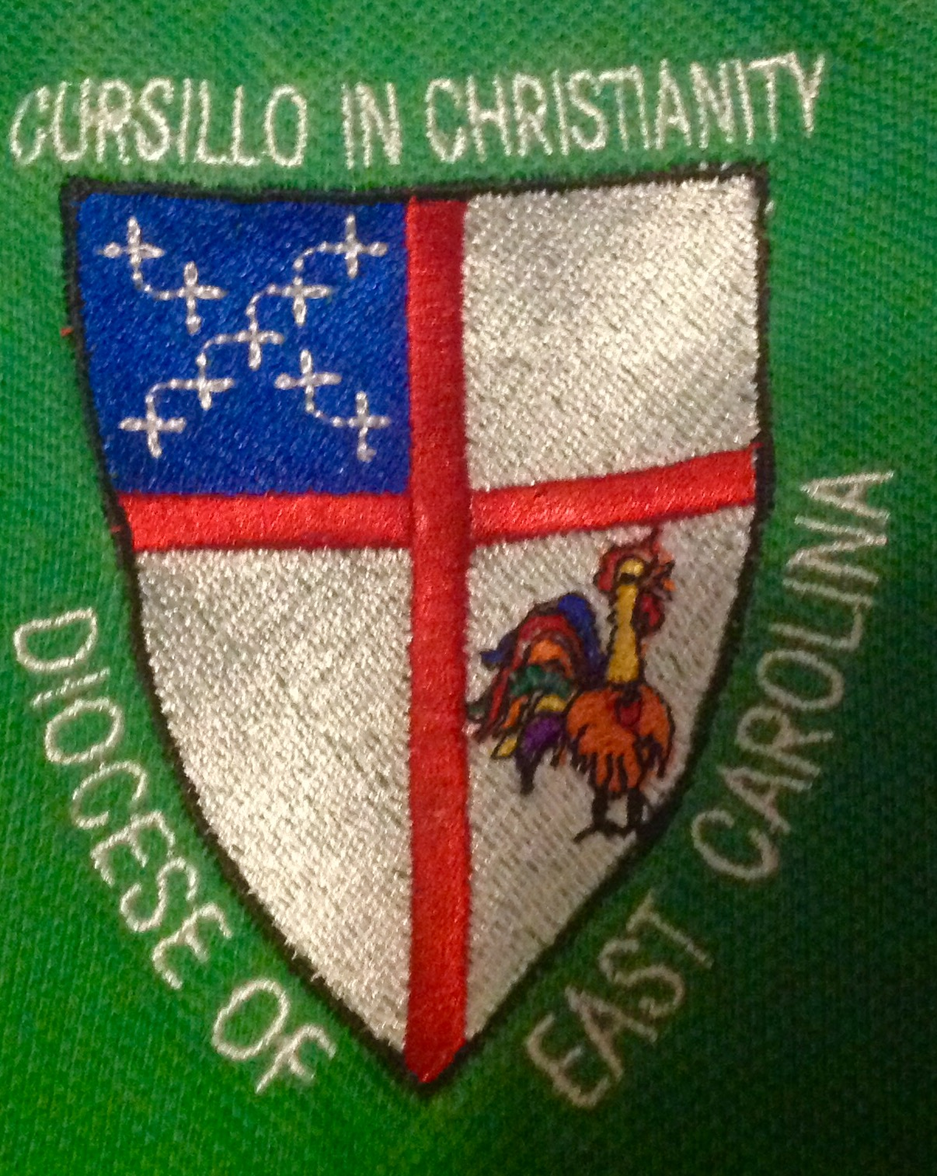

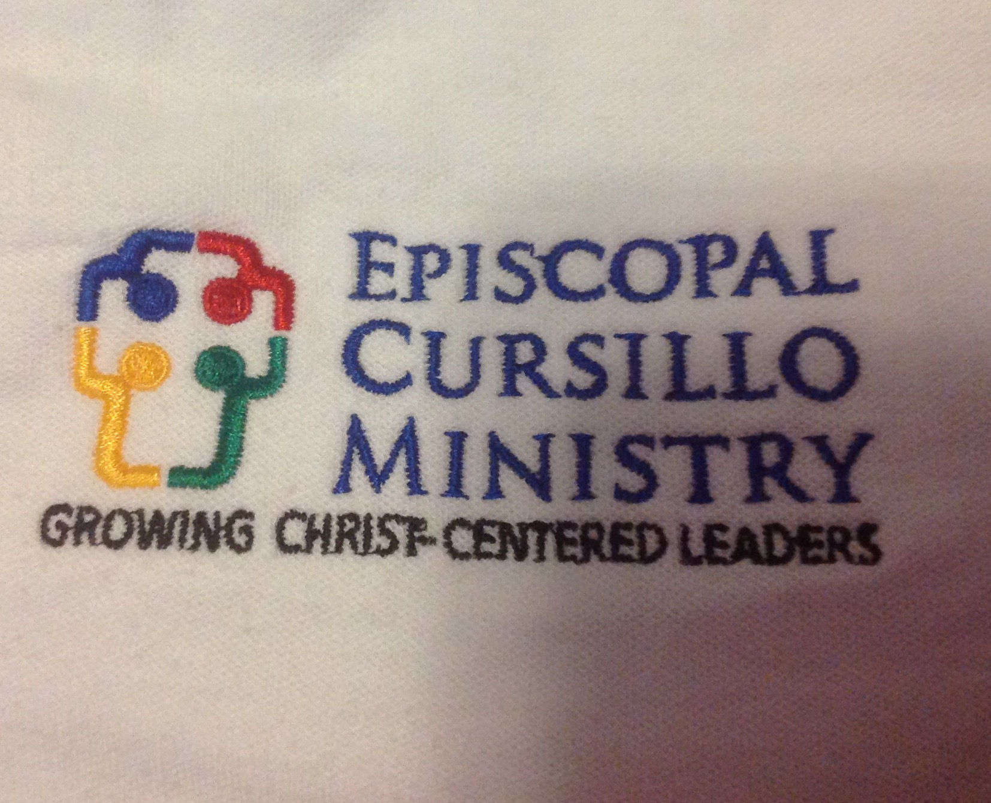
For the Episcopal Cursillo Ministry please indicate size
Episcopal Cursillo Ministry
This only comes in white.
XS | S | M | L | XL | XXL | XXXL

Cost per shirt:
Size XS – XL $25.00
Size XXL – XXXL $28.00

Please send completed order form and payment to:
Mary Mac Shields
211 Marshall Rd
Fayetteville, NC 28303
Make checks payable to “Cursillo in Christianity.” Shirts will be delivered at the next possible Secretariat meeting or can be mailed for $5 per shirt
Ladies please note the shirts are men sizes, so when ordering keep this in mind.

